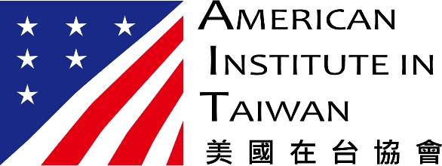

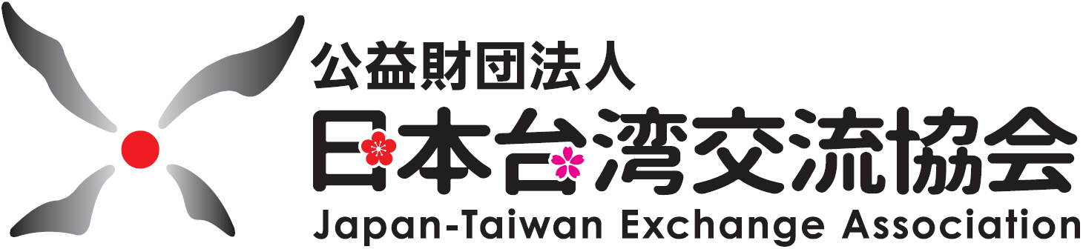

JOINT PRESS RELEASE

SUPPORT FOR TAIWAN’S MEANINGFUL ENGAGEMENT WITH THE WORLD HEALTH ORGANIZATION AND PARTICIPATION AS AN OBSERVER IN THE WORLD HEALTH ASSEMBLY

We, the American Institute in Taiwan, the Japan-Taiwan Exchange Association and the Australian Office in Taipei, wish to express our support for Taiwan’s meaningful participation in the work of the World Health Organization, and Taiwan’s participation as an observer in the World Health Assembly.

Taiwan is experiencing a challenging time right now, as health authorities work diligently to counter its first significant threat from community transmission. Nonetheless, Taiwan’s early response to the emergence of COVID-19, its rigorous testing strategies, robust border measures and its information transparency remain a public health success story, and contributed to one of lowest incidences of the disease in the world.

As COVID-19 cases continue to increase around the world, Taiwan shared its expertise with others during the Global Cooperation and Training Framework (GCTF) forum on “COVID-19 Vaccine Rollout: Experiences and Challenges” on 18 May in Taipei, with participants joining virtually from around the world. Sponsored by Taiwan’s Ministry of Foreign Affairs, the American Institute in Taiwan, the Japan-Taiwan Exchange Association, the Australian Office in Taipei and other partners, the forum was designed to share best practices with health practitioners from participating countries.

Taiwan has received well-deserved acclaim for its accomplishments on global health security, including in the G7 Foreign and Development Ministers’ Communique earlier this month. However, as this year’s 74th session of the World Health Assembly commences in Geneva, we also recognize that Taiwan is largely excluded from the world’s international health system.

Taiwan’s meaningful participation in the World Health Organization’s forums and technical committees would not only benefit the 24 million people of Taiwan, it would benefit our citizens and the world. The pandemic has highlighted Taiwan’s capacity to research, develop, produce and supply effective treatments, including some promising vaccine candidates. The pandemic has also highlighted Taiwan’s importance as a reliable supplier of quality personal protective equipment. Taiwan’s donations of such equipment to countries in need demonstrates a willingness and capability to help.

As global infection rates continue to soar, the world cannot afford to exclude any population from international health networks. Global monitoring and early warning systems that detect emerging infectious diseases need to be inclusive. Vaccinations need to be made available everywhere to be fully effective.

We therefore call for the substantive participation of all active members of the international health community in the World Health Assembly. Excluding some members compromises global health and safety. It’s time to bring Taiwan on board.

